Thesis on Plant Health Monitoring System

-By

GAURAV KUMAR JAISWAL(E21CSEU0309)

ANUSH DASARI REDDY(E21CSEU0270)

C.KARTHIK(E21CSEU0264)

CHITRAKAVI SURYA SRINIVASA VAMSEE(E21CSEU0263)

Submitted to the School of

Computer Science Engineering and Technology

for Bachelor of Technology in Computer Science and Engineering

at the

Bennett University, Greater Noida 201310, Uttar Pradesh, India

April 2023

○c Bennett University 2023. All rights reserved.

Author By: Gaurav Kumar Jaiswal, Anush Dasari Reddy, C. Karthik, Chitrakavi Surya Vamsee…………….

School of Computer Science and Engineering and Technology

April 22, 2023

Certified By: ……………………………….………………………………………………………………………………………………………

Mohd. Abuzar Sayeed

Assistant Professor

School of Computer Science and Engineering and Technology

Accepted By: …….……………………….………………………………………………………………………………………………………

Mohd. Abuzar Sayeed

Assistant Professor

School of Computer Science and Engineering and Technology

Thesis on Plant Health Monitoring System

-By

GAURAV KUMAR JAISWAL(E21CSEU0309)

ANUSH DASARI REDDY(E21CSEU0270)

C.KARTHIK(E21CSEU0264)

CHITRAKAVI SURYA SRINIVASA VAMSEE(E21CSEU0263)

Submitted to the School of Computer Science Engineering and Technology

for Bachelor of Technology in Computer Science and Engineering at the

Bennett University, Greater Noida 201310, Uttar Pradesh, India

ACKNOWLEDGEMENT

We would like to take this opportunity to express my/our deepest gratitude to my/our mentor, Dr. Mohd. Abuzar Sayeed (Assistant Professor, SCSET) for guiding, supporting, and helping us in every possible way. We were extremely fortunate to have him as our mentor as he provided insightful solutions to problems we faced, thus contributing immensely towards completing this capstone project. We would also like to express our deepest gratitude to VC, DEAN, HOD, faculty members, and friends who helped us complete this thesis.

**ABSTRACT**

As the use of IoT is slowly and steadily coming into the field of agriculture and environment conservation as a result monitoring the ecology with the help of these technological solutions is a massive breakthrough. One such application of this technology was used to research and develop a plant health monitoring system that uses multiple sensors like soil moisture sensor, humidity sensor, temperature sensor, and in advanced cases pH as well as Co2 levels sensors and collects real-time data when the sensors are placed correctly into a potted plant or in a particular space in an agriculture field and thus gives real-time data on the portable devices like a laptop or a smartphone whenever the entire systems are powered up.

The system uses microelectronic devices like microcontrollers and Wi-Fi module which processes the instruction in the form of code sent by the user which then programs the entire setup to fetch data from the sensors and then display it to the user and based on the observation allowing the user to take actions like for example if the soil is lacking in moisture or humidity then with just one click of a button from the laptop or the mobile phone the user or the owner can water the plants and bring the required level of temperature and humidity well as the moisture levels of the soil for healthy growth of plants.

Keywords—IoT, agriculture, environment, sensors, real-time data, healthy growth,

microcontroller

Contents 1

1. Introduction……………………………………………………………1
2. Literature survey……………………………………………………....2
3. Objectives……………………………………………………………..3
4. Methodologies………………………………………………………....3
5. Results…………………………………………………………………3
6. Discussions…………………………………………………………….4
7. Figures and Diagrams………………………………………………….5
8. References……………………………………………………………..8
9. Introduction

A plant health monitoring system is an IoT-based device built by connecting various sensors and other devices like 9v battery and Led devices and a mini Motor through the means of jumper wires(female-female) to the Wi-Fi-based microcontroller called ESP8266 Wi-Fi module the module is further connected to the computer(laptop)by using a micro USB to USB cable from where the program to run the entire setup is written in Arduino ide and the further uploaded into the module. It must be noted that the entire setup must be connected to the laptop via the Wi-Fi module so that the Wi-Fi connection via the laptop is established and hence we can control this monitoring system further using our mobile device (laptop or smartphone).

The plant health monitoring systems in real-time use a lot of sensors or a lesser number of sensors depending upon the requirements of the group of beneficiaries, the ESP2866 module can collect this data and transmit it over the WI-FI to a server or cloud platform. As a result, it enables real-time tracking and monitoring of the vitals and hence allows users to decide when to water the plants.

One of the major advantages of the use of the ESP8266 module which can be specially catered to agriculture needs is its low power consumption which also makes It suitable for battery-powered other applications hence allowing for continuous monitoring without the need for frequent battery changes.

As a result, boosting the shelf life of the plants.

The following plant health monitoring systems on which this thesis is based are made of the following microelectronic and electronic equipment.

1. Relay: this is an electrical switch that is used o control the devices or systems based on the sensor data or the command provided by the user to the WI-FI module through a third-party application. The purpose of the relay used here is to turn the water pump on and off.

For example, if the moisture levels are below the desired levels, then the user must water the plants and for that whenever the command is given the relay switches to complete the circuit and hence the water starts flowing.

1. NodeMCU ESP8266: NodeMCU is an open-source firmware and development kit based on the ESP8266 wireless fidelity module. It’s a low-cost, low-power system-on-a-chip microcontroller. It can be easily programmed in C++ language by importing the necessary libraries in the Arduino ide software.

1

1. Soil moisture sensor: A soil moisture sensing module is an electronic device used in IoT-based plant health monitoring systems to measure the moisture content of the soil. It consists of a moisture sensor probe that is inserted into the soil and connected to a microcontroller or other electronic device. This sensor works by measuring the electrical resistance of the soil which can vary depending on the moisture content. The moisture content is then calculated by the microcontroller based on the resistance reading, and the data is transmitted wirelessly to a cloud-based platform for monitoring and analysis.
2. Jumper wires: the following setup of female-to-female jumper wires are used to connect various sensors via its pins to the pins of the various nodes of the node MCU Wi-Fi module.\\
3. DHT11: The DHT11 sensor consists of a thermistor and a capacitive humidity sensor, along with a digital signal processor that converts the analog readings from the sensors into digital signals. The sensor has a temperature range of 0°C to 50°C and a humidity range of 20% to 90% RH. The DHT11 sensor communicates with a microcontroller or other electronic device using a single-wire serial interface, which makes it easy to interface with microcontrollers and other electronic devices. The data from the sensor is transmitted as a digital signal, which makes it less susceptible to noise and interference than analog sensors.
4. Literature surveys

This literature survey consists of research on similar topics related to developing simple to highly sophisticated monitoring systems like connecting to alarm bells and programming the same when the moisture levels are too low or too high and further connecting to weather monitoring applications that predict the weather in upcoming days and hence cautions the owner related to how much water should be provided to plants.

Below are the mentioned hyperlinks of the sites which cater to the above idea:

1. "IoT-Based Smart Agriculture: A Review" by A. Sharma et al. (2021)

Link: <https://www.mdpi.com/2071-1050/13/3/1326>

1. "Internet of Things for Agriculture: A Comprehensive Review" by S. Singh et al. (2020)

Link: <https://www.mdpi.com/2071-1050/12/23/9958>

1. "IoT-Enabled Precision Agriculture: A Systematic Review" by R. Usman et al. (2019)

Link: <https://ieeexplore.ieee.org/document/8856682>

2

1. “Internet of Things for Agriculture: A Review of Applications, Challenges, and Future Directions” by D. Kumar et al. (2018)

Link: <https://www.mdpi.com/1424-8220/18/8/2676>

1. “Smart Farming: Agriculture Technologies and Applications” by P. Zhang et al. (2018)

Link: <https://ieeexplore.ieee.org/document/8431614>

1. OBJECTIVES

The main objective is to provide easy access to the parameters affecting crop fields from anywhere around the globe. To control the wastage of irrigation water and hence also to enhance the shelf life and quality of the plant. The objective is to replace the old time-consuming method of the irrigation system with an efficient automatic system.

IV.METHADOLOGY

To achieve this solution, a relay module is interfaced to the Node MCU board at the receiver end while on the transmitter end, a set point on the soil moisture sensor is considered. If the moisture of the soil falls below the set point, the relay switches on and allows the mini-dc pump to conduct and supply water to the crop fields. Once the required moisture level is reached, the soil moisture sends the signal to the relay module via NodeMCU. The relay switches off and thus switches off the mini –dc pump. Also, the humidity and temperature of the atmosphere are measured using the DHT-11 sensor. Outputs are displayed on the BLYNK app as well as on the Thing Speak cloud platform for future reference. The flow chart depicting the methodology. It shows how the control shifts from the soil moisture sensor to the pump depending on whether the soil moisture is the same as required by the crop.

V. RESULTS

Based on the study and the observations the setup was evaluated on the parameters to sense the humidity, temperature, and moisture levels and it achieved it hereby. The system will be further examined and thoroughly studied and researched to make the setup more dynamic and complex to enhance user awareness and get every detail like the pH levels of the soil, UV radiation detection, etc.

3

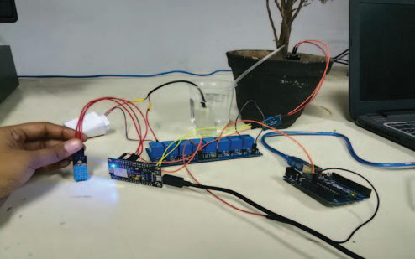

Figure 1: The setup of the plant health monitoring system

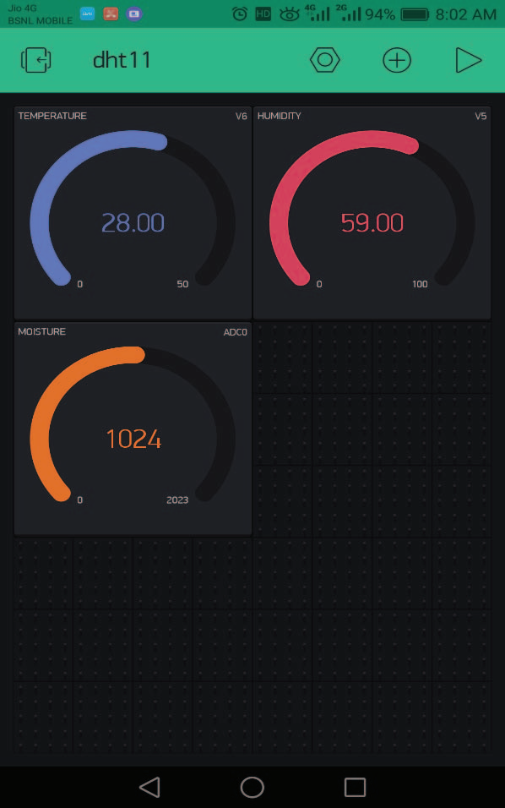

Figure 2: the result displayed on the Blynk app which is connected to the Wi-Fi module through a Wi-Fi connection.

VI. DISCUSSIONS

1. Importance of the need for plant health monitoring systems: Indoor plants are high in duty and the number of people buying indoor plants is increasing day by day. But people face a lot of problems in raising indoor plants as taking care of these indoor plants is not easy and they even die from a cause that is difficult to predict. According to the National Gardening

4

1. Association, people from all age groups ranging from 20 and above are completely obsessed with indoor plants. It states that in the US alone the sale of indoor plants has increased by 50% during the last three years which now stands at a value of $1.7 billion in 2019. The need for indoor plants
2. is increasing day by day so is the problem to take care of these plants. To raise and maintain the health of indoor plants various factors need to be monitored which include- soil moisture, temperature, humidity, and soil ph.
3. Benefits and challenges: Aside from the Western world in the context of India, such systems can be highly beneficial to the farming community as we know that every year India is one of the largest producers of food grains, fruits, and vegetables, etc despite having improper farming systems and monitoring of the same which results in huge losses of resources and depriving especially small farmers which have to depend upon rainfall for the irrigation of the crops. The introduction of this technology and its adoption at subsidized prices can help farmers to maintain the moisture contents and the ph levels by allowing them to not overuse resources like water and fertilizers for high yield of the crops and hence significantly increasing the farm productivity with keeping the natural resources required for the growth of crops in check.
4. Future Directions: For future developments, more sensors like LDR sensors, and UV radiation detection sensors can be further added to the setup to protect plants and crops from harmful radiation which can potentially degrade the life span of the plant and in the case of agriculture can reduce the yield. Aside from the hardware aspect, Machine learning algorithms can also be implemented for a certain types of plants and crops depending upon the past data and hence allowing the user to judge how much resources are needed to be put in at what time and for how long.

VII. DIAGRAMS

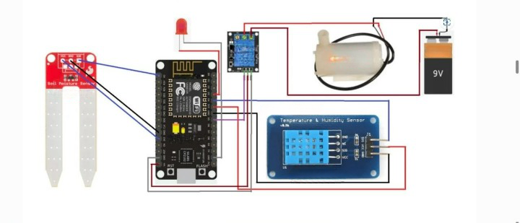

FIGURE 3) CIRCUIT DIAGRAM OF THE SETUP

5

Contents of the diagram:

1. 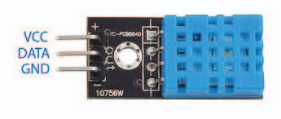

**DHT 11 Temperature and Humidity Sensor**

Soil moisture sensor

3) 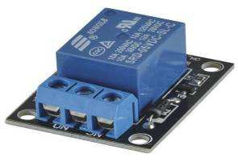

**Relay**

**4)**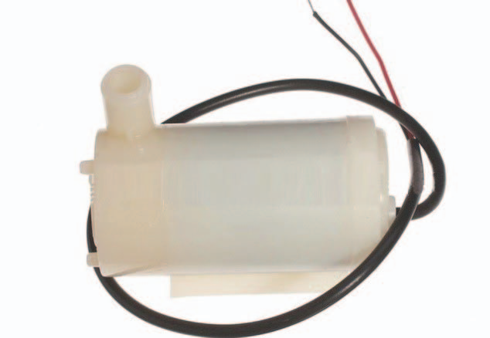

**Mini-Water Pump**

6

**

**NodeMCU ESP8266 WI-FI MODULE**

1. 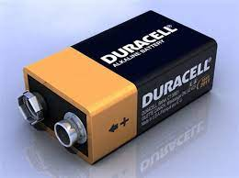

9V DC BATTERY

7

VIII. REFERENCES

1. J. Lee, et al. "A Smart Farming System for Monitoring Plant Growth Using IoT Technologies." IEEE Access, vol. 7, pp. 156968-156978, 2019. DOI: 10.1109/ACCESS.2019.2946789
2. R. N. Sharma, et al. "Plant Health Monitoring System using IoT." Proceedings of the 3rd International Conference on Internet of Things and Connected Technologies (ICIoTCT), pp. 137-141, 2019. DOI: 10.1007/978-981-15-5972-6_20
3. A. M. Abd El-Latif, et al. "Automated Plant Health Monitoring System Using Image Processing Techniques." Proceedings of the 13th International Conference on Computer Engineering and Applications (ICCEA), pp. 111-116, 2020. DOI: 10.1145/3424455.3424480
4. M. Y. Kim, et al. "Real-Time Plant Health Monitoring System Based on Wireless Sensor Networks and Decision Trees." Sensors, vol. 19, no. 21, 2019. DOI: 10.3390/s19214637
5. S. S. Cui, et al. "Development of a Remote Sensing-Based Plant Health Monitoring System." Journal of Applied Remote Sensing, vol. 12, no. 2, 2018. DOI: 10.1117/1.JRS.12.026010
6. A. R. Khan, et al. "An Automated Plant Health Monitoring System for Early Detection of Biotic and Abiotic Stresses." Journal of Applied Remote Sensing, vol. 14, no. 2, 2020. DOI: 10.1117/1.JRS.14.026524

8